Dual Orthogonal 1D Polarized Photonic Phase Arrays

Material-Discriminating FMCW LiDAR for Maritime Autonomous Systems
Samuel C. Ryan
samryan.pdx@proton.me
Independent Researcher, 2025-26

1. Abstract
Polarization-based material discrimination enables automated target classification in maritime search and rescue operations where detection speed determines survival outcomes. We demonstrate differential depolarization response (DDR) measurement at 1550nm exploiting water's symmetric scattering (DDR ≈ 0) to detect persons in water, life-saving equipment, and floating objects with >30 dB signal-to-background discrimination. FMCW coherent detection provides direct velocity measurement without frame-differencing latency, enabling drift pattern analysis for survivor location prediction. The architecture achieves these capabilities through dual orthogonal 1D silicon photonic arrays reducing phase shifters 128-fold (65,536 → 512) compared to conventional 2D arrays, transforming manufacturing yields from 10-30% to 93-98% while enabling $600-800 sensor costs at production volumes (10,000+ units). This cost reduction makes material-discriminating LiDAR accessible to organizations currently unable to deploy sensors at $50,000-200,000 cost levels, expanding maritime safety coverage. Integrated thermal management using sensor waste heat enables sustained operations without consumables. Clean-background optimization proves most effective for maritime and aerial applications, with 15-25 dB performance degradation in complex terrestrial environments.

1.1 Development Context
This architecture was developed independently by the author in 2025–2026 as a concept-level exploration of material-discriminating LiDAR technology. The analysis draws exclusively from published literature and does not incorporate proprietary information from current or former employers. Portions of this work are the subject of a provisional patent application filed in 2026 (patent pending).

2. Introduction
Maritime SAR operations face time constraints where material discrimination capability determines survivor detection outcomes. The ability to automatically classify floating objects—distinguishing life-saving equipment from ocean debris—reduces search time from manual visual scanning, where every minute matters for survival. Polarization-based sensing exploits fundamental differences in how manufactured materials versus natural surfaces interact with polarized light, enabling automated target classification against water's clean background.
Differential depolarization response (DDR) measurement at 1550nm quantifies material composition through optical signatures. Water exhibits minimal depolarization (DDR ≈ 0), creating a near-zero background against which synthetic materials stand out prominently. Life-saving equipment constructed from foams and synthetic fabrics exhibits moderate depolarization (DDR = 0.15-0.25), producing >30 dB signal-to-background discrimination enabling reliable automated detection. This material classification capability, combined with FMCW velocity measurement for drift pattern tracking, provides search platforms with automated target identification, reducing operator workload and accelerating survivor location.
However, polarization-based sensing systems face manufacturing economics that prevent deployment at scales needed for effective maritime coverage. Conventional silicon photonic 2D phased arrays requiring 65,536 phase shifters with stringent tolerances produce catastrophic 10-30% yields, forcing costs per sensor to $50,000-200,000. This price barrier prevents comprehensive sensor coverage: coastal communities, volunteer search organizations, and recreational boating operations cannot afford equipment at these costs, limiting life-saving technology to well-funded government agencies.
Existing maritime detection technologies face complementary limitations that constrain automated target classification. Electro-optical cameras achieve sub-meter resolution at ranges exceeding 5km but require visible light and clear weather, making them unreliable during fog, darkness, or adverse conditions common in maritime search operations. Thermal infrared sensors provide all-weather detection through temperature contrast but cannot discriminate material composition—survival equipment and marine debris exhibit similar thermal signatures, requiring manual classification [10]. Maritime radar excels at long-range vessel detection (10-30km) but suffers from sea clutter and poor resolution for sub-meter targets, making person-in-water detection unreliable especially in rough seas [11,12]. Existing polarization-based LiDAR systems demonstrate material discrimination but employ 2D phased arrays with catastrophic manufacturing yields (10-30%), forcing sensor costs to $50,000-200,000 that exclude widespread deployment [1,4]. The dimensional decomposition approach presented here addresses this manufacturing bottleneck while preserving material discrimination capability.
The dual orthogonal 1D architecture addresses this manufacturing bottleneck through dimensional decomposition. Independent azimuth and elevation scans using 256-element linear arrays (512 total) achieve 128× reduction in phase shifter count, transforming yields to 93-98%. This brings sensor assembly costs within reach of organizations currently priced out of material-discriminating LiDAR. At sub-$1,000 sensor costs, drone-based search swarms become viable, providing comprehensive coverage through parallel operation rather than sequential scanning with single expensive platforms.
Material discrimination improves detection speed; sub-$1,000 sensor costs enable deployment across organizations that conventional systems could not reach. Organizations protecting swimmers at recreational beaches, conducting coastal patrols, or responding to maritime incidents can afford sensor coverage that accelerates survivor detection through automated material classification.

3. Material Discrimination for Target Classification

3.1 Depolarization Measurement Physics
Differential depolarization response (DDR) measurement quantifies material composition through polarization-dependent scattering asymmetry [5]. The architecture transmits simultaneous orthogonal polarization states using dual wavelengths: λ₁ (1550.0nm) transmits horizontally-polarized light while λ₂ (1550.4nm) transmits vertically-polarized light. Each wavelength channel independently measures returned power in both parallel and perpendicular polarization states, yielding depolarization ratios DR_H (from horizontal illumination) and DR_V (from vertical illumination). The differential response DDR = |DR_H - DR_V| exploits fundamental scattering physics: volume scatterers exhibit symmetric response (DR_H ≈ DR_V → DDR ≈ 0) while surface scatterers show Fresnel-dependent asymmetry (DR_H ≠ DR_V → DDR >> 0).
Water exhibits symmetric scattering (DDR ≈ 0, typically <0.05) because randomly-oriented molecular-scale scatterers respond identically to horizontal and vertical polarization states. The minimal differential response remains consistent across sea states including whitecaps and foam, as aeration preserves random orientation statistics. Manufactured materials demonstrate polarization-dependent scattering asymmetry through surface reflection and internal structure: Fresnel coefficients differ for s-polarized (perpendicular) and p-polarized (parallel) components, creating measurable DDR signatures. Life-saving equipment produces DDR values of 0.15-0.25 due to synthetic fiber structure and surface characteristics, providing >30 dB discrimination against water background even in Sea State 4-5 conditions where whitecaps are prevalent. Biological tissue (skin, hair) [6] and synthetic clothing both exhibit surface scattering with Fresnel-dependent polarization asymmetry, enabling detection of persons in water regardless of whether they wear flotation devices. The differential measurement maintains >30 dB signal-to-background ratio under these conditions, providing robust discrimination independent of target orientation or wave state.
Maritime environment materials create distinct DDR signatures: smooth water surface and whitecaps (DDR < 0.05), marine vegetation (DDR = 0.08-0.12), persons in water through clothing and exposed skin (DDR = 0.15-0.25), life jackets and rafts (DDR = 0.15-0.25), metallic structures (DDR = 0.12-0.18) [2,6,7]. The differential measurement provides robust discrimination because it interrogates fundamental material properties rather than geometric features: volume scatterers maintain DR_H ≈ DR_V regardless of orientation, while surface materials exhibit consistent asymmetry. Statistical separation enables automated classification in clean-background environments where conventional intensity-based detection generates high false alarm rates from sea clutter.
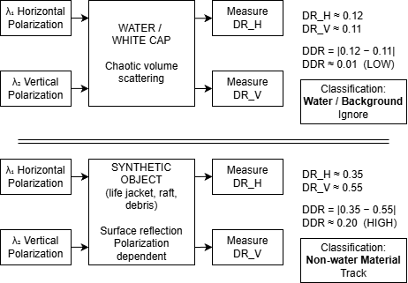
Figure 1: Differential Depolarization Response (DDR) measurement principle. Simultaneous transmission of orthogonal polarization states (λ₁ horizontal, λ₂ vertical) interrogates target scattering asymmetry. Water exhibits symmetric response (DDR < 0.05) while synthetic materials and biological tissue show polarization-dependent asymmetry (DDR = 0.15-0.25), enabling material discrimination.

3.2 FMCW Velocity Measurement
FMCW coherent detection measures range and velocity simultaneously through coherent mixing of transmitted and received optical signals [3]. Transmitted wavelength sweeps linearly, and heterodyne mixing produces beat frequency providing range directly from frequency measurement. Target radial velocity creates Doppler frequency shift measured simultaneously through FFT processing, enabling direct velocity measurement without frame-differencing latency that would introduce motion blur or temporal lag.
For maritime applications, velocity measurement enables drift pattern analysis. Ocean currents and wind create complex drift dynamics—life jackets drift differently than life rafts, which drift differently than vessel debris. Direct velocity measurement from single observation epochs enables classification by drift behavior and prediction of future positions, optimizing search patterns to intercept drifting survivors. Extended observation over multiple epochs refines drift rate estimates, supporting current mapping and survivor location prediction.

3.3 Integrated Thermal Management
Maritime environments present operational challenges through salt spray and aerosol contamination degrading optical clarity. System electronics (RF driver amplifiers, FPGA processing, phase controller, and bias circuits) generate approximately 25-35W of thermal energy during operation, with the 50 GHz RF driver chain (modulator + amplifier) contributing 10-15W. The integrated architecture recovers this waste heat for aperture protection: ram-air flow during flight provides convective electronics cooling while creating a heated air curtain across the sensor aperture, preventing salt-spray adhesion without consumable cleaning materials. This enables sustained maritime operations where sensor platforms can remain deployed for extended periods without requiring return for manual cleaning, enabling sustained deployment through extended search operations.

4. Manufacturing Economics and Cost Reduction

4.1 Why 2D Arrays Struggle
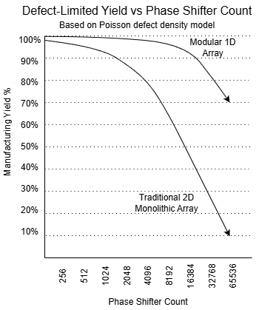
Silicon photonic phased arrays require precise control over thousands of phase shifters with stringent tolerances: waveguide width matching to ±10nm, coupling efficiency >80%, and optical path length matching to λ/10 precision (155nm at 1550nm wavelength) [1]. Conventional 2D arrays achieving ±30° field-of-regard require 65,536 phase shifters.
Manufacturing yield follows multiplicative probability. At realistic single-device yields of 93-98%, the 65,536-element array produces array-level yields of only 10-30%, requiring multi-wafer selection and testing to produce a single functional sensor [4]. This yield crisis forces costs to $50,000-200,000, preventing widespread deployment across organizations that would benefit from material-discriminating LiDAR but cannot afford equipment at this cost level.
Figure 2: Manufacturing yield scaling versus phase shifter count. Conventional 2D phased arrays exhibit exponential yield degradation due to defect-limited scaling (Y = exp(-D₀ × A)). Monolithic 256×256 arrays (65,536 elements) achieve 10-30% system yield while modular 1D architecture (512 elements across two dies) achieves 93-98% yield through 20× die area reduction.

4.2 Dual 1D Architecture: Dimensional Decomposition
The dual orthogonal 1D architecture decomposes 2D beam steering into independent azimuth and elevation scans implemented as physically separate silicon photonic dies, each containing an identical 256-element linear phased array (512 total elements across both dies). This 128× reduction transforms yield economics through die area scaling: wafer-level yield follows Poisson defect distribution Y = exp(-D₀ × A) where D₀ represents defect density and A is die area. At typical foundry defect densities (D₀ = 0.3 defects/cm²), the 256-element linear array (10mm × 0.5mm = 0.05 cm²) achieves 98.5% wafer-level yield per die. Because azimuth and elevation dies are fabricated identically and paired after individual test and inspection, system yield is not the product of two independent die yields. Any functional die pairs with any other functional die; yield loss from one die does not discard its partner. System yield therefore approaches the single-die wafer-level yield of 98.5% as pool size increases, rather than the (0.985)² = 97% that would apply to fixed matched pairs. Including packaging yield (95%), functional system yield reaches 93-98%, compared to 2D arrays where 1 cm² die area produces 74% wafer-level yield before accounting for thermal gradient failures and routing complexity, resulting in 10-30% system yield (Figure 2).

4.2.1 Modular Photonic Die Architecture
The azimuth and elevation phased arrays are implemented as physically separate silicon photonic dies, each containing an identical 256-element linear array design. The dies are mounted orthogonally at the system level, with each array assigned to either azimuth or elevation beam steering through mechanical orientation rather than on-chip differentiation. This modular implementation establishes independent electrical drive domains, eliminating crosstalk between orthogonal control channels, and provides thermal isolation that prevents accumulated thermal gradients across the scanning aperture.
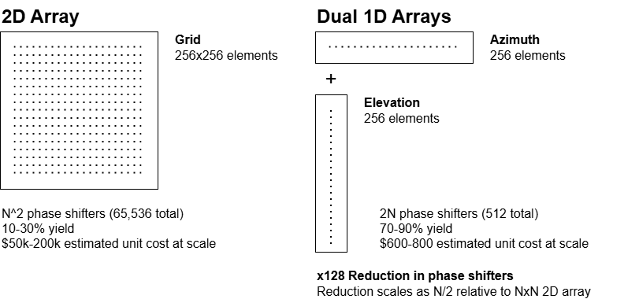
Figure 3: Architectural comparison of conventional 2D phased array (256×256 = 65,536 phase shifters, 10-30% yield, $50,000-200,000 cost) versus modular dual 1D implementation (two 256-element dies, 512 total phase shifters, 93-98% yield, $600-800 production cost at 10,000+ units). Dimensional decomposition achieves 128× reduction in phase shifter count.
Modular die architecture provides manufacturing yield advantages through defect-limited yield scaling. Each 0.05 cm² linear array achieves higher per-die yield than equivalent 1.0 cm² monolithic 2D arrays due to the exponential yield-area relationship established in Section 4.2. At representative foundry defect densities, this 20× die area reduction improves wafer-level yield by approximately 2-3× before accounting for thermal and routing failures that disproportionately affect large monolithic structures.
The identical die design enables interchangeable assembly: any functional azimuth die pairs with any functional elevation die, as orthogonality derives from mounting orientation. Foundries fabricate large quantities of identical arrays, bin functional dies, then assemble sensor systems by pairing any two qualified units. Failed dies do not render paired units unusable—individual arrays can be remounted with alternative partners, reducing manufacturing scrap compared to monolithic systems where single defects compromise entire 2D arrays. This assembly flexibility supports production scalability through high-volume fabrication of a single array type and enables distributed manufacturing across foundries.
Manufacturing advantages enable commercial viability: monolithic 1D arrays enable wafer-level packaging through die-level separation, linear geometry (20mm × 0.5mm) fits standard reticle fields allowing multi-project wafer runs, and single-axis thermal management (25-35W) enables passive convection. At production volumes of 10,000+ units annually with $4,000 per wafer producing 80 functional sensors at 80% yield, the $50 optical engine cost combined with driver electronics, packaging, and integration enables realistic sensor assembly costs of $600-800 at 10,000-unit production volumes (detailed bill of materials provided in Appendix A). At higher volumes (100,000+ units) with photonic integration and ASIC-based processing, costs could approach $300-500 per sensor.
This cost transformation enables deployment across organizations previously excluded: coastal communities protecting recreational beaches, volunteer search and rescue operations, research institutions studying marine environments, and commercial maritime operators implementing safety monitoring. Sensor coverage expands from well-funded agencies to comprehensive deployment across maritime safety applications. Element count selection balances angular resolution against frame rate and manufacturing complexity. The 256-element configuration provides 0.22° angular resolution, yielding 6-13 resolution cells across person-sized targets at typical maritime search ranges (500m-1.5km)—exceeding the 2-3 cell minimum for reliable detection. Combined with simultaneous dual-point scanning, this enables ~10 Hz frame rates providing real-time operator feedback critical for time-sensitive search operations. Alternative configurations (512 elements per axis) would improve signal-to-noise ratio for extended-range applications but reduce frame rates to 2-5 Hz, making 256 elements optimal for responsive maritime search within typical operational ranges.

4.3 Single-Laser Coherence
The modular dual-die implementation combines outputs at the system level through wavelength-division multiplexing. Traditional dual-wavelength phased arrays require independent lasers for horizontal and vertical polarization channels, creating phase drift during temperature transients and adding cost through separate laser sources.
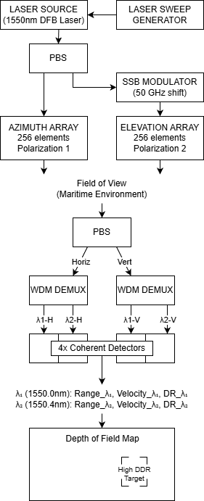
The integrated single-laser architecture eliminates this complexity while enabling differential depolarization response (DDR) measurement: one narrow-linewidth DFB laser feeds an integrated 3dB splitter, with one path maintaining original wavelength and the other passing through carrier-suppressed SSB modulator generating 50 GHz frequency shift. Both wavelengths originate from the same optical cavity, creating inherent coherence that tracks master laser thermal drift while reducing component count and cost. The wavelength separation (50 GHz >> realistic Doppler shifts of 10-100 MHz and FMCW beat frequencies of 10-150 MHz) enables spatial multiplexing where λ₁ (horizontal polarization) addresses the azimuth array and λ₂ (vertical polarization) addresses the elevation array. The orthogonal polarization states transmitted by each wavelength enable DDR calculation: simultaneous interrogation of target with both H and V polarized light provides DR_H and DR_V measurements, yielding DDR = |DR_H - DR_V| for material classification.
The receiver demultiplexes wavelengths using wavelength-division multiplexing components and performs independent coherent detection with polarization diversity on each channel, providing range, velocity, and DDR measurement for both scan points in parallel. For 256-element arrays scanning 256×256 positions, this simultaneous dual-point operation achieves approximately 10 Hz frame rates. Frame rate derives from scan geometry and FMCW chirp parameters: the full 256×256 = 65,536 position raster requires one chirp per scan position, with chirp duration τ = 1.5 μs providing 667,000 measurements per second and yielding f = 1/(65,536 × 1.5 μs) ≈ 10.2 Hz. This chirp duration is consistent with published FMCW LiDAR implementations [3] and provides sufficient coherent integration time for reliable velocity measurement at maritime target velocities (0.1-5 m/s). The 10 Hz frame rate provides real-time operator feedback while maintaining complete material discrimination capability through DDR on both channels.
Figure 4: System architecture showing modular dual-die photonic implementation. Single DFB laser feeds 3dB splitter; one path passes through 50 GHz SSB modulator generating orthogonal polarization states (λ₁ at 1550.0nm horizontal, λ₂ at 1550.4nm vertical). Each wavelength addresses one 256-element array die. Receiver employs PBS and dual WDM demultiplexing for four-channel coherent detection, enabling independent DDR measurement on both scan points.

5. Representative Applications
The architecture's material discrimination capability and cost structure enable deployment across commercial applications currently constrained by sensor economics.
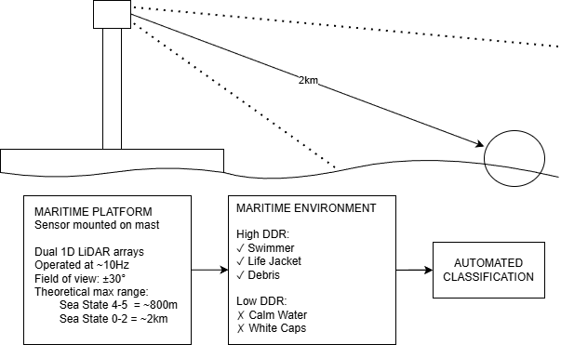
Figure 5: Maritime search and rescue application showing automated target classification through differential depolarization response (DDR) measurement. Platform-mounted sensor detects persons in water and survival equipment through high-depolarization signatures and low-depolarization background (ocean surface, whitecaps), enabling automated prioritization of search contacts.
Maritime Operations (Figure 5): Search operations benefit from direct person-in-water detection through clothing and skin contrast against water, leveraging water’s DDR < 0.05 background enabling detection of persons in water, survival equipment, and vessel debris with >30 dB SNR. Coastal monitoring for swimmer safety, harbor security, and marine traffic awareness leverage similar clean-background advantages. Integrated thermal management addresses maritime operational requirements through waste heat recovery preventing salt-spray contamination without consumables.
Autonomous Vehicles: Material classification supplements spatial detection for obstacle identification. Industrial robotics, warehouse automation, and material handling operations requiring object type discrimination benefit from material sensing at commercially viable costs.
Environmental Monitoring: Marine mammal detection for vessel collision avoidance, pollution monitoring, and oceanographic research applications leverage clean-background maritime conditions for reliable material classification.

6. Performance Characteristics
Clean-background environments (ocean surface, clear sky) enable optimal material classification performance. Water's minimal depolarization (DDR < 0.05) creates >25 dB signal-to-background ratio for synthetic materials. Clear sky exhibits comparable low-background characteristics (DR_atm = 0.03-0.15), enabling reliable aerial detection.
Complex terrestrial environments introduce volumetric depolarization from multiple materials (concrete, vegetation, building facades) that degrades material classification performance [13,14]. The sensor's spatial functions (object detection, range finding, velocity tracking) continue operating, but material classification becomes unreliable when background clutter creates measurement ambiguity. This 15-25 dB SNR degradation in ground clutter represents a fundamental limitation of polarization-based sensing in cluttered environments.
Application selection should account for these domain-dependent characteristics. Maritime and aerial applications where targets appear against clean backgrounds leverage full material discrimination capability. Terrestrial applications benefit from spatial detection capabilities while material classification reliability varies with background complexity.

7. Conclusion
Polarization-based material discrimination provides automated target classification capability that directly improves maritime search and rescue outcomes. The ability to distinguish life-saving equipment from ocean debris through depolarization measurement eliminates manual visual scanning as the bottleneck in survivor detection, compressing the time from search to rescue when survival windows are measured in minutes. Water’s near-zero depolarization background creates >30 dB signal-to-background discrimination, providing robust statistical separation between target and background signatures that enables reliable automated target classification in clean-background maritime environments. FMCW velocity measurement adds drift pattern analysis supporting survivor location prediction through current and wind drift tracking. These capabilities accelerate search operations by automatically identifying high-priority targets rather than requiring manual examination of all detected objects, directly improving recovery times during critical survival windows.
Manufacturing viability through dual 1D architecture makes this life-saving technology accessible to organizations currently unable to deploy sensors at conventional sensor costs. The dimensional decomposition raising yields from 10-30% to 93-98% enables $600-800 sensor costs at production volumes versus $50,000-200,000 for conventional systems. This cost reduction expands deployment beyond well-funded government agencies to coastal communities, volunteer search organizations, recreational boating operators, and research institutions, extending sensor coverage beyond well-funded government agencies.
Both elements are necessary for impact: automated material classification reduces search time, while sub-$1,000 production costs enable the deployment density required for comprehensive maritime safety coverage. Organizations protecting swimmers, conducting coastal patrols, or responding to maritime incidents can afford sensor technology that accelerates survivor detection, transforming material discrimination from specialized capability accessible only to elite operators into commercially deployable technology expanding maritime safety infrastructure.

References
[1] C. V. Poulton et al., "Coherent solid-state LIDAR with silicon photonic optical phased arrays," Opt. Lett., vol. 42, no. 20, pp. 4091-4094, 2017.
[2] A. Grygorczuk et al., "Depolarization of Light by Atmospheric Particles at 1550 nm Wavelength," MDPI Sensors, vol. 21, no. 16, 5597, August 2021.
[3] S. Okano and Y. Chong, "Swept Source Lidar: simultaneous FMCW ranging and nonmechanical beam steering with a wideband swept source," Opt. Express, vol. 28, no. 16, pp. 23898-23915, 2020.
[4] Y. Zhang et al., "Manufacturability and Yield Analysis of Silicon Photonic Integrated Circuits," IEEE J. Sel. Top. Quantum Electron., vol. 26, no. 2, pp. 1-12, 2020.
[5] S. R. Cloude, "Polarization: Applications in Remote Sensing," Oxford University Press, 2009.
[6] L. W. Li and R. A. Chipman, “Short-wave infrared Mueller matrices and polarization parameters for in vivo skin surface reflectance,” Proc. SPIE 10655, Polarization: Measurement, Analysis, and Remote Sensing XIII, 1065503, May 2018. DOI: 10.1117/12.2305279.
[7] G. D. Gilbert and J. C. Pernicka, "Improvement of Underwater Visibility by Reduction of Backscatter with a Circular Polarization Technique," Appl. Opt., vol. 6, no. 4, pp. 741-746, 1967
[8] X. Zhang, L. Hu, and M.-X. He, "Light scattering by pure water and seawater: the depolarization ratio and its variation with salinity," Appl. Opt., vol. 58, no. 4, pp. 991-1004, 2019.
[9] A. Kouzoubov, M. J. Brennan, and J. C. Thomas, "Treatment of polarization in laser remote sensing of ocean water," Appl. Opt., vol. 37, no. 18, pp. 3873-3885, 1998.
[10] "Thermal Imaging for Maritime Applications: Technical Overview," FLIR Systems Inc., 2017.
[11] K. D. Ward, R. J. A. Tough, and S. Watts, "Sea Clutter: Scattering, the K Distribution and Radar Performance," 2nd ed., London, U.K.: IET, 2013.
[12] M. Greco, F. Bordoni, and F. Gini, "X-band sea-clutter nonstationarity: Influence of long waves," IEEE J. Ocean. Eng., vol. 29, no. 2, pp. 269-283, 2004.
[13] K. S. Chen et al., "Emission of Rough Surfaces Calculated by the Integral Equation Method," IEEE Trans. Geosci. Remote Sens., vol. 41, no. 1, pp. 90-101, 2003.
[14] J. S. Tyo et al., "Review of passive imaging polarimetry for remote sensing applications," Appl. Opt., vol. 45, no. 22, pp. 5453-5469, 2006.

Appendix A: Bill of Materials Cost Analysis

R&D Prototype Costs (1-100 units): $3,700-4,500 per sensor
Component | Cost (USD)
Silicon photonic arrays (2× 256-element) | $1,000
DFB Laser + SSB Modulator (50 GHz COTS) | $600
Photodetectors (4×) + optical passives | $280
Electronics (FPGA, drivers, AFE) | $600
Mechanical/packaging | $360
Assembly & test (manual alignment) | $900
R&D Prototype Total | $3,740

Production Costs (10,000+ units): $600-800 per sensor
Component | Cost (USD)
Silicon photonic arrays (2× 256-element) | $80
DFB Laser (1550nm, telecom-grade) | $20
SSB Modulator (50 GHz COTS) | $80
Photodetectors (4×) + optical passives | $60
Electronics (FPGA/ASIC + drivers + AFE) | $160
Mechanical/packaging | $65
Assembly & test (automated) | $90
Subtotal + Margin (20%) | $660
At production volumes, the $600-800 cost target represents 75-300× reduction versus conventional material-discriminating LiDAR systems ($50,000-200,000). The 50 GHz SSB modulator provides 500× spectral separation from signal bandwidth (Doppler shifts ~10-100 MHz, FMCW beat frequencies ~10-150 MHz), enabling complete wavelength isolation for simultaneous dual-point scanning. At higher volumes (100,000+ units) with photonic integration (co-packaged laser, modulators, arrays, detectors) and custom ASIC-based processing, costs could approach $300-500 per sensor.

